1. **简介Introduction**

非制冷红外热像仪对温度敏感，无论模组出厂前测温标定如何精确，当用户将模组集成到整机中后，由于热分布的变化、光学结构的变化（加窗口片等），必然引起一定的测温偏差。因此需要在整机中进行二次标定。

When the user integrates the module into the whole machine, it will inevitably cause a certain temperature measurement deviation due to the changes of thermal distribution and optical structure (add window, etc.). Therefore, Secondary calibration& Lid pattern noise correction is required in the whole machine.

1. **“锅盖”二次标定Lid pattern noise correction**

* 需要器材：温度均匀的哑光平面（室温即可，无需控温）。最好是表面喷砂（减少镜面反射）发黑（提升发射率，同样是为了减少反射）处理后的金属片（常见的铝合金即可）。

Equipment: matte surface with uniform temperature (room temperature, no temperature control). Preferably black anodized metal sheet (aluminum alloy).

* 用户操作：将平板放置在镜头前5mm左右，不要接触到镜头，向模组发送“锅盖标定”指令，等待若干秒即可。

Operation: place the plate 5mm in front of the lens（do not touch the lens）, send the "Lid pattern noise correction" instruction to the module, and wait for several seconds.

* 详情见资料包中的软件说明部分。

See additional documentation for details.

*每一台都需要标定，即使看起锅盖不明显，也会影响边缘测温结果

* Each one needs to be calibrated, even if the Lid pattern noise is not obvious——It will affect the temperature measurement results of the edge

1. **测温二次标定Secondary calibration**

**单点标定法One-point secondary calibration**

模组光学结构未变化，仅热分布发生改变

The optical structure of the module does not change, but only the thermal distribution changes

* 需要器材：1个黑体

Equipment: One set of blackbody

* 用户操作：1.黑体设定在某一温度（普通工业测温：高增益模式35摄氏度，低增益模式200摄氏度；人体测温：35摄氏度）；2.模组距离黑体面25cm，成像中心对准黑体中心，黑体温度均匀区域在画面不少于9*9个像素。3.发送标定命令。4.停止出图。

Operation: 1. The black body is set at a certain temperature (industrial : 35 ° C in high gain mode, 200 ° C in low gain mode; Creature: 35 ℃); 2. The module is 25cm away from the black surface, the imaging center is aligned with the center of the black body, and the uniform temperature area of the black body is no less than 9*9 pixels in the picture. 3. Send the calibration command. 4. Stop streaming.

*每一台都需要标定

* Each one needs to be calibrated

**两点标定法****Two-point secondary calibration**

光学结构和热分布都发生变化

Both optical structure and thermal distribution change

* 需要器材：2个黑体

Equipment: Two sets of blackbody

* 用户操作：1.黑体分别设定在某一温度（普通工业测温：高增益模式20/120摄氏度，低增益模式100/400摄氏度；人体测温：30/40摄氏度）；2.模组距离黑体面25cm，成像中心对准黑体中心，黑体温度均匀区域在画面不少于9*9个像素。3.发送标定命令。4.停止出图。

Operation: 1. The black body is set at a certain temperature (industrial : 20/120 ° C in high gain mode, 100/400 ° C in low gain mode; Creature: 30/40 ℃); 2. The module is 25cm away from the black surface, the imaging center is aligned with the center of the black body, and the uniform temperature area of the black body is no less than 9*9 pixels in the picture. 3. Send the calibration command. 4. Stop streaming.

* 详情见资料包中的软件说明部分。

See additional documentation for details.

*每一台都需要标定

* Each one needs to be calibrated

*工业高增益模式的用户，如果对5℃以下的低温目标测温精度比较关心，可将第一个温度点温度降低到10℃。

* Industrial high-gain mode: If you are concerned about the temperature measurement accuracy of the low-temperature target below 5℃, you can lower the temperature of the first temperature point to 10℃.

*如果窗口片透过谱在7um下迅速截止，会改变模组温度响应曲线，窗口片选型时需要注意。下图中，紫色曲线对应的窗口片二次标定效果较好。

* If the window transmission spectrum is rapidly cutoff at 7um, the module temperature response curve will be changed, so attention should be paid to the selection of the window. In the figure below, the window corresponding to purple curve has a better secondary calibration effect.

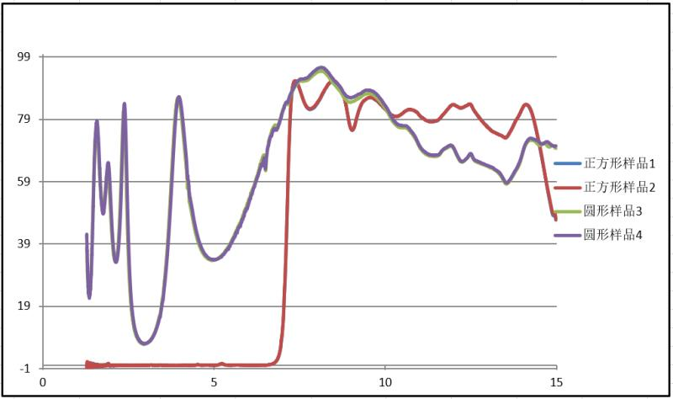

1. **二次标定周期Secondary calibration period**

* MEMS红外焦平面阵列探测器性质会随使用时间有一定漂移，因此间隔一段时间需要重新校准。

The properties of a MEMS infrared sensor drift with time, so recalibration is required at an interval of time.

* 睿创集团自主研发的MEMS红外焦平面阵列探测器具有世界先进水平，寿命可达12年。普通测温产品不需要重新校准。部分高精度测温应用，3~5年校准一次即可。

Our products come to the world's advanced level, with a life span of up to 12 years. Normal applications do not require recalibration. High precision temperature measurement applications, 3~5 years to calibrate once.

**五、二次标定延时时间设置Setting of delay time for secondary calibration**

* 测温两点标定、单点标定和锅盖标定需要严格执行标定流程和表格《二次标定延时时间.xlsx》中规定延时时间，否则会出现标定不准确或者软件崩溃的现象。

Two-point Secondary calibration, one-point Secondary calibration and Lid pattern noise correction need to strictly implement the calibration process and the delay time specified in the table "Setting of delay time for secondary calibration", otherwise inaccurate calibration or software crash will occur.